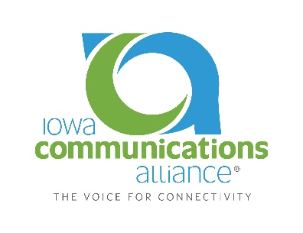
4201 westown Pkwy, Suite 130
West Des Moines, IA 50266
Ph: 515-867-2091
www.IACommunicationsAll.org

CARRIER MEMBER APPLICATION
Company Information

Company Name:
Contact Name:
Mailing Address:
City / State / Zip:
Telephone: |  |  | Fax:
Website: |  |  | E:Mail:
Year Founded |  |  | Number of Employees
Description of Company Services:

How did you learn about the Iowa Communications Alliance?
Who referred you?
Are you a certificated local exchange carrier? |  | ___ Yes ___ No

Contact Information

First Contact Name: |  | Title:
Telephone / Fax: | / | E-Mail:
Second Contact Name: |  | Title:
Telephone / Fax: | / | E-Mail:
Third Contact Name: |  | Title:
Telephone / Fax: | / | E-Mail:

Dues Information
Carrier member dues are $1,000 annually. The membership year runs from January to December.
All applications for membership are subject to approval by the Board of Directors. Once your application is approved, ICA will send an invoice for membership dues.

For Iowa Communications Alliance office use only:

Date Received:_______________________ Amount Received:_____________________

Board Approval:_______________________ Check Number:_______________________

